**Optimization Techniques**

**NAME**: TITHI PATEL

**ENROLLMENT NUMBER: 18BECE30558**

**5 TH SEM CE SHIFT 2**

**PRACTICAL 14 and 15:** Write a function for Golden Section and Fibonacci Search Method.

--------------------------------------------------------------------------------------------------------------------------

**Golden Section**

function y=gs(f,i,l,n)

g=(sqrt(5)-1)/2;

for i=1:n

x1=i+g*(l-i);

x2=l-g*(l-i);

if f(x1)>f(x2)

l=x1;

else

i=x2;

end

i=i+1;

endfor

y=(x1+x2)/2;

fprintf('x1=%f , x2=%f ',x1,x2);

endfunction

**OUTPUT:**

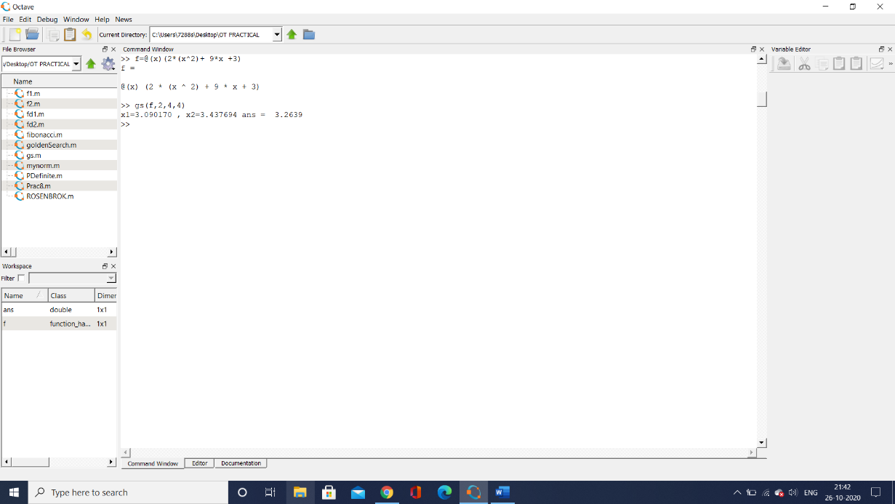

---------------------------------------------------------------------------------------------------------------------------

**Fibonacci Search Method**

unction []=fs(f,in,l,N)

first = 0

second = 1

i = 1

p = []

F = []

while(i <= N+1)

total = first + second

F(i) = total

first = second

second = total

i = i+1

end

i = 1

while(i <= N)

temp1 = (N - i + 1)

temp2 = (N - i + 2)

temp = round(F(temp1))/round(F(temp2))

p(i) = 1 - (temp)

i = i+1

end

itr = 1

while(itr <= N)

fprintf("itr=%f\n",itr)

a1 = in + p(itr)*(l-in)

b1 = in + (1-p(itr))*(l-in)

if(f(a1)<f(b1))

l = b1

end

if(f(a1)>f(b1))

in = a1

end

itr = itr + 1

fprintf("a1=%f, b1=%f\n",in,l)

end

printf('The values after Fibonacci search are ')

fprintf("a=%f, b=%f\n",in,l)

endfunction

**OUTPUT:**

